**PRACTICUM REPORT**

**ALGORITHM AND DATA STRUCTURES**

**MODUL 5 : SORTING**



**Disusun Oleh :**

**ONIC AGUSTINO**

**L200234275**

**X**

**INFORMATICS ENGINEERING**

**FACULTY OF COMMUNICATION AND INFORMATICS**

**UNIVERSITAS MUHAMMADIYAH SURAKARTA**

**YEARS 2024/2025**

**1.11 Questions**

1.Create a program to sort an array of students based on NIM, whose elements are made from the MhsTIF class, which you created earlier.

* **Program Code**

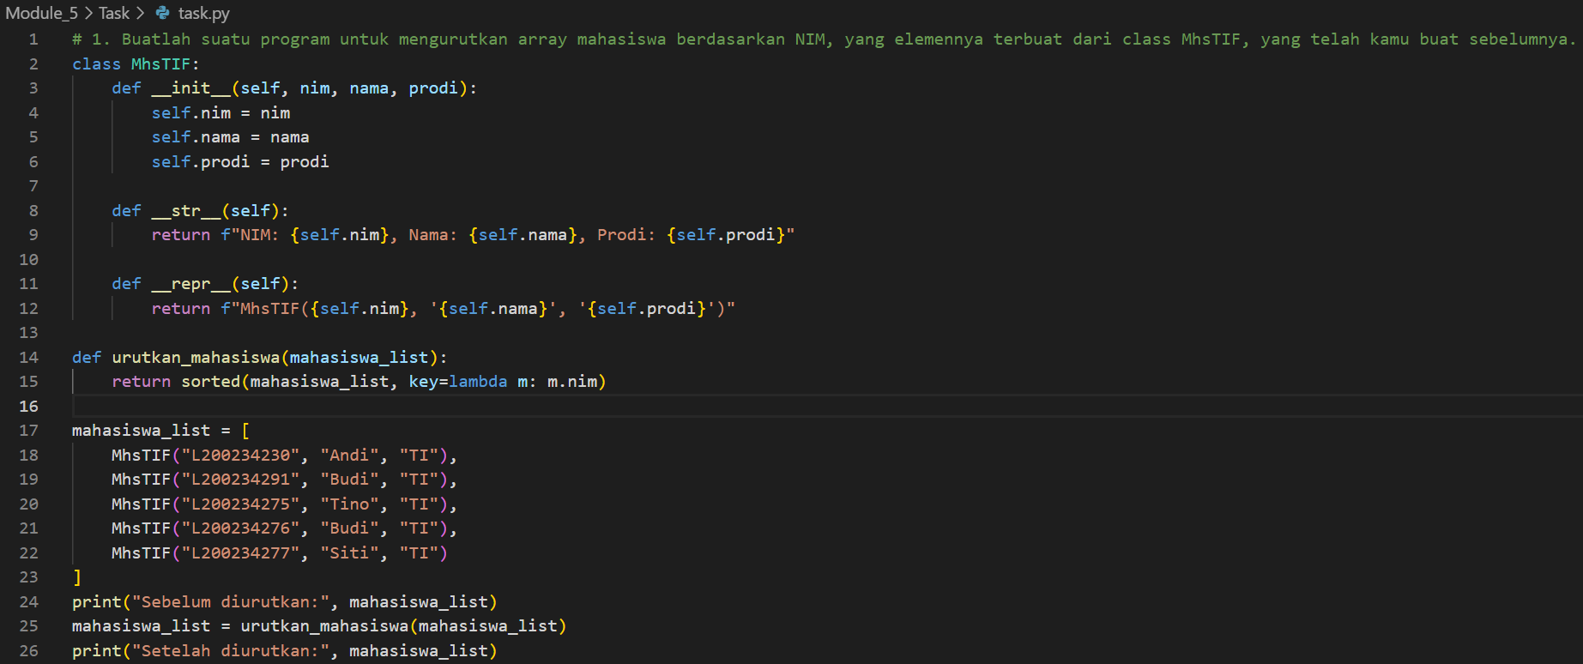

Code 1.1 the code.

|  |
| --- |
| *This program creates a class called MhsTIF to represent student data, including attributes like student ID (NIM), name, and study program. Then, a function urutkan_mahasiswa() is defined, using the sorted() method to sort the student list based on their NIM. Initially, a list of students is created using multiple MhsTIF objects, each containing their respective NIM, name, and study program. Before sorting, the student list is displayed using the print() function. Once sorting is completed, the updated and sorted student list is shown again.* |

* **Practicum Result Screenshot**



Gambar 1.2 the results

1. For example, there are two sorted arrays A and B. Create a program to efficiently combine the two arrays into a sorted array C.

* **Program Code**

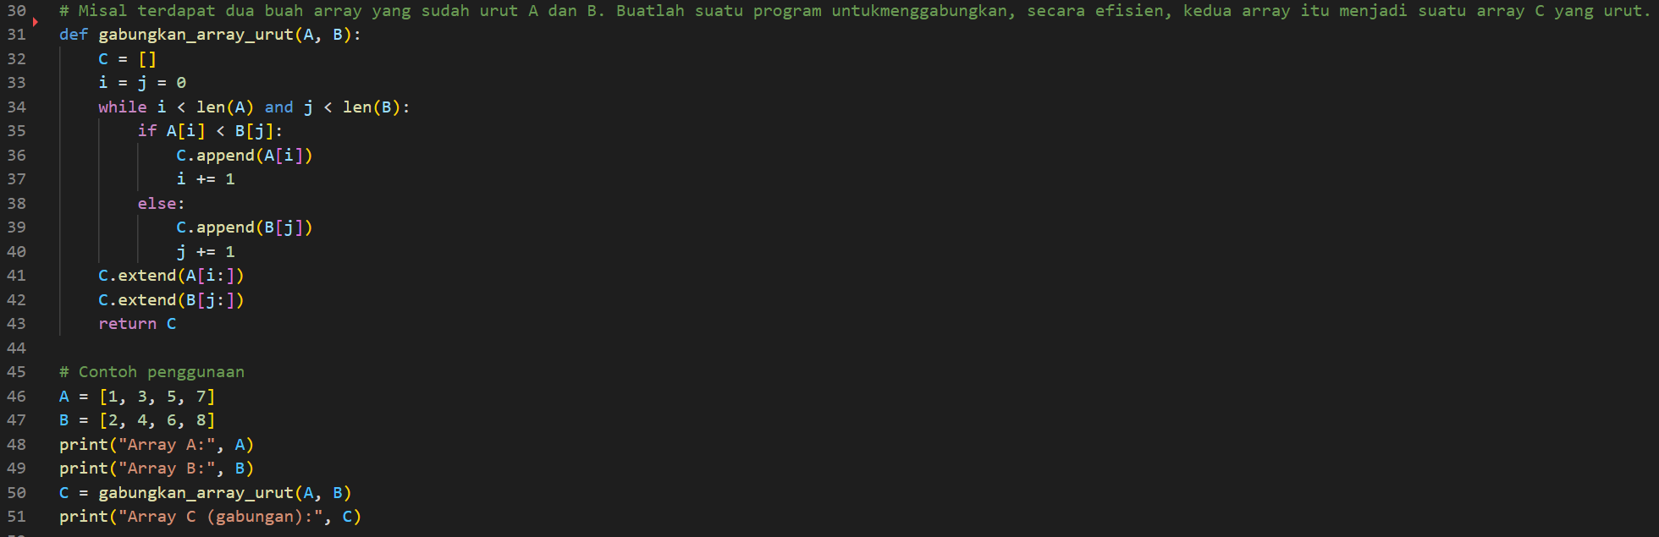

* 1. the code.

|  |
| --- |
| *This program efficiently merges two sorted arrays, A and B, into a single sorted array, C. It initializes an empty list C and uses two pointers, i and j, to traverse A and B while comparing elements one by one. The smaller element is appended to C, and the corresponding pointer is incremented until one of the lists is fully traversed. The remaining elements of either A or B are then added to C to complete the merging process. Finally, the merged and sorted array C is displayed.* |

* **Practicum Result Screenshot**

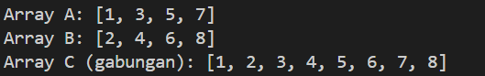

* 1. the result

1. You might have guessed that bubble sort is slower than selection sort and also insertion sort. But which is faster, selection sort or insertion sort?7

To start investigating, you can compare the time it takes to sort a large array, say 6000 elements long.

* **Program Code**

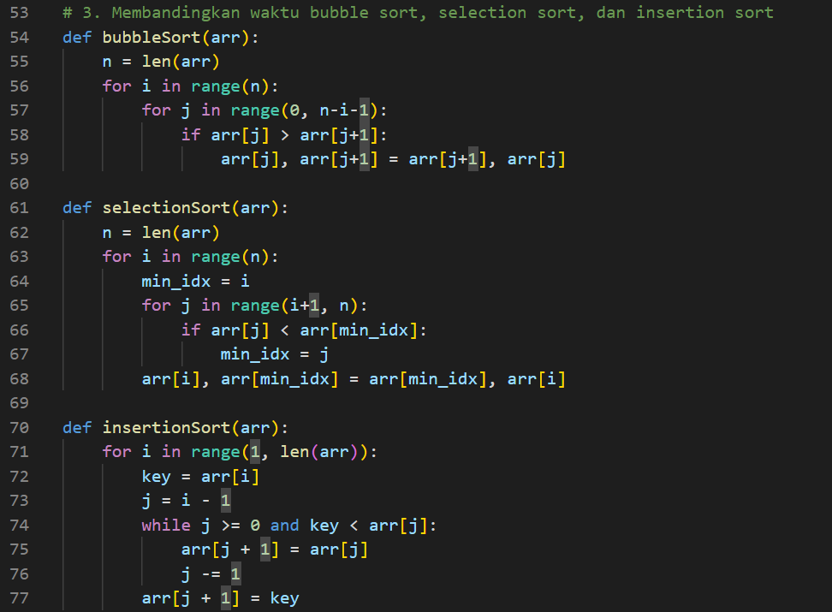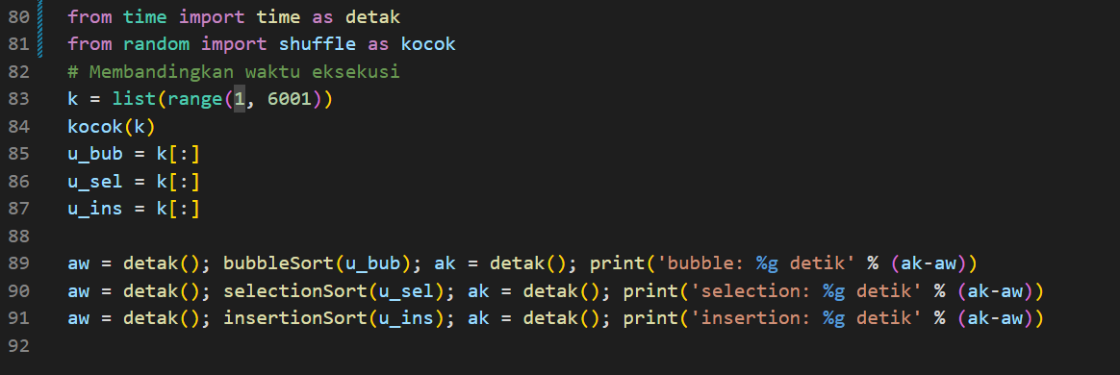

* 1. the code

|  |
| --- |
| *This program compares the execution time of three sorting algorithms:* ***Bubble Sort, Selection Sort, and Insertion Sort****. Each sorting function processes an input array by applying its respective method to reorder the elements in ascending order. The program generates a shuffled list containing numbers from 1 to 6000, then applies all three sorting algorithms on separate copies of this list. Using Python's time() function, it measures how long each algorithm takes to sort the list. Finally, the execution times are printed for comparison, helping to analyze which sorting algorithm performs faster.* |

* **Practicum Results Program**

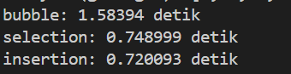

3.1 the results.